

Rosanna Cubs –
Whittlesea SES – at Mernda
Tuesday 12th October, 6:30pm

On Tuesday 12th October, we’ll be visiting the Whittlesea State Emergency Service (SES), which is based at Mernda.

While there we’ll get the chance to learn about what the SES does to protect lives and property.

Details:
- Meet at the Hall around 6:30pm, ready to leave at 6:45 pm sharp.
- Session at the SES will be from 7:15-8:15pm.
- Pickup from the Hall at around 8:40-8:50pm (approx).
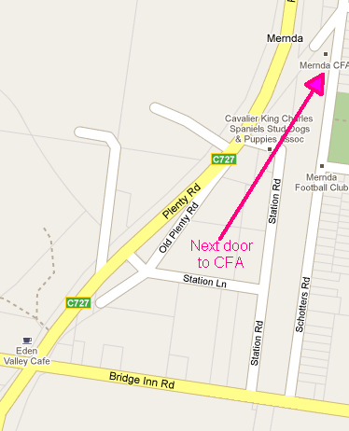
- Full uniform required – in addition bring a jacket etc., or as appropriate for the weather on the night
- Some parents will be required for transport. Please notify Akela on arrival at the Hall if you’re able to provide transport if required.

While we’re meeting at the Hall, for the benefit of those providing transport, a map is is shown here. The SES is on Schotters Rd in Mernda, next to the CFA
Melway Ref: 390 J8

Akela
9434 7594
0411 121 495
akela@rosannacubs.org

